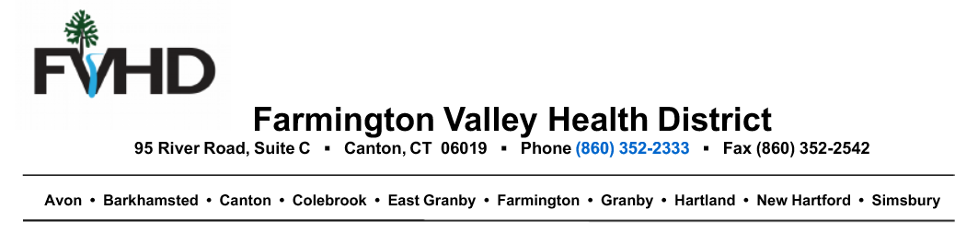
March 17, 2020
To: Septic Installers, Professional Engineers, Well Drillers & Septic Pumpers
From: Farmington Valley Health District
Due to the COVID-19 pandemic, our environmental health team priorities are shifting to support our response to the COVID19 response, so it is NOT business as usual!
We are requesting your patience with scheduling soil testing & septic inspections. More time will also be needed for plan reviews, 19-13 B100 reviews and well approvals. Our goal is to still perform this work for you, but we will only be sprinkling our calendars with it until the COVID 19 pandemic ends.
Below are links that are important sources of information to you since you work with wastewater. Please read them and keep your self-protected by following a few additional simple steps:
- Stay home if you are sick
- Used social distancing (keep a minimum of 6’ away from other people)
- Use frequent handwashing, hand sanitizer when unable to wash & use good personal hygiene, i.e. covering your cough/sneeze with elbow or tissue & disinfecting frequently touched surfaces
Thank you for you understanding and stay well!
https://portal.ct.gov/Coronavirus
https://www.cdc.gov/coronavirus/2019-ncov/php/water.html

